

DLD Lab-10
7-Segment Display


NATIONAL UNIVERSTIY OF COMPUTER AND EMERGING SCIENCES, FAST- Peshawar Campus
Department Of Computer Science
EL1005 – Digital Logic Design-Lab
SEMESTER SPRING 2026

Contents
1. Objectives: 2
2. Outcomes: 2
3. Equipment Required: 2
4. Seven Segment LED Display: 2
5. Two types of 7 Segment Displays 3
6. Working of 7-Segment Display (LED & LCD) Circuit 6
7. 7-Segment Truth Table 11
8. 7-Segment Display Decoder Circuit 15
9. Application of BCD to Display Decoder 15
10. IC-74LS47 Implementation 16

Objectives:
Familiarization with operation of 7-segment display
Interfacing with BCD to Seven Segment Code converter IC
Design of BCD to 7-segment code converter circuit

Outcomes:
Students should be able to
Interface a 7 segment display with BCD to 7 segment code converter IC
Design and implement the BCD to 7 segment code converter using Kmaps

Equipment Required:
- DEV-2765E Trainer Board / Multisim 14.2 /Logic.ly
- 7448 BCD to 7-segment code converter
- Common-cathode 7-segment LED (single and double digit) Display

Seven Segment LED Display:
Decimal digits from 0 to 9 can be shown using a 7–segment LED display unit. This unit shows one decimal digit using 7 LED segments to form the numbers from 0 to 9. These 7-segments are a, b, c, d, e, f, g
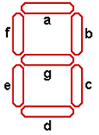
7-Segment Display

A BCD-to-seven-segment decoder (7448) is a combinational circuit that converts a decimal digit in BCD to an appropriate code for the selection of segments in an indicator used to display the decimal digit in a familiar form. The seven outputs of the decoder (a, b, c, d, e, f, g) select the corresponding segments in the display, as shown in Fig.(a) . The numeric display chosen to represent the decimal digit is shown in Fig.(b) .

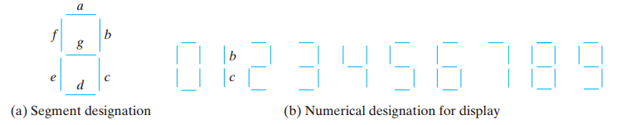

Two types of 7 Segment Displays

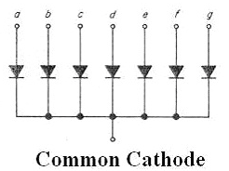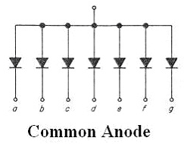

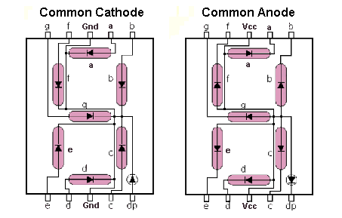

Different decoder IC with different display
7447 (BCD to 7-segment Converter ) outputs are active low , it is used with common anode display .
7448 (BCD to 7-segment Converter ) outputs are active high , it is used with common cathode display .

Pin configuration

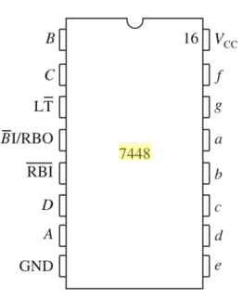
7448-IC Pin Configuration

The pin connections of the common-cathode 7-segment single digit display are below:

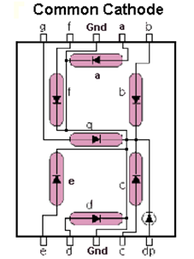

Procedure

- Connect the trainer with the power supply
- Mount the BCD to 7-segment driver IC 74LS48 on the trainer board
- Connect pins of the IC according to the diagram
- Connect pin 16 to +5 V (Power Supply) and pin 8 to GND (Ground).
- Apply all combinations of inputs leaving pins 3,4,5 unconnected and see the corresponding decimal digit on the 7-segment LED display .Show these to the instructor

Design of BCD to seven segment code converter

Using truth tables and Karnaugh maps, design the BCD-to-seven-segment decoder using minimum number of gates.


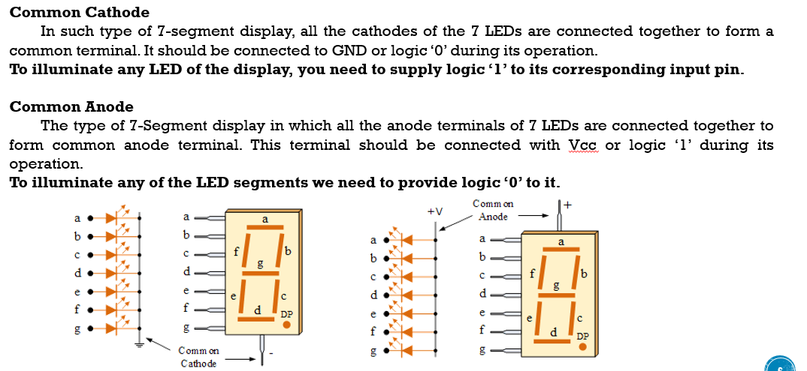


Working of 7-Segment Display (LED & LCD) Circuit
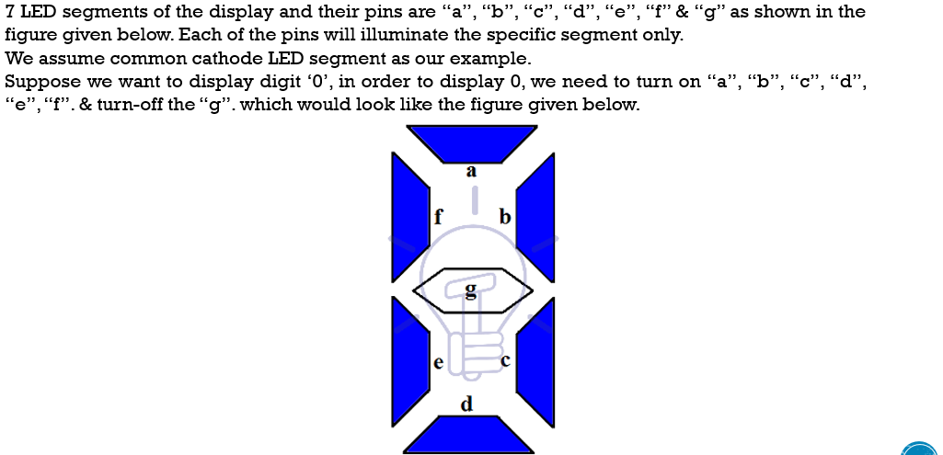

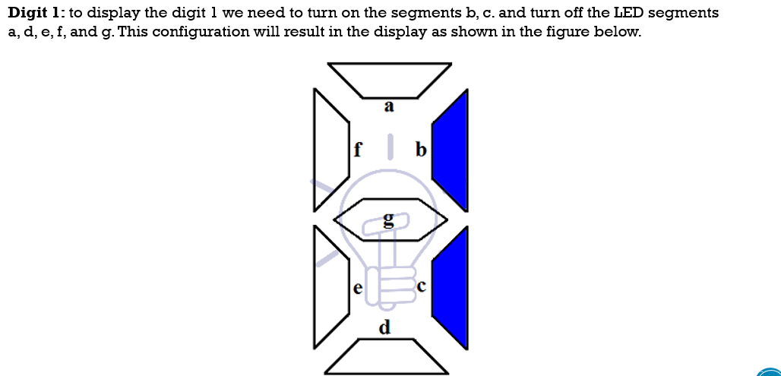
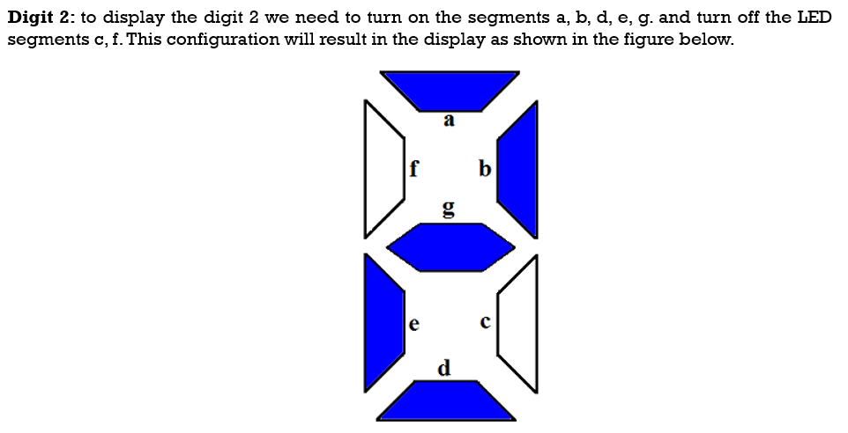
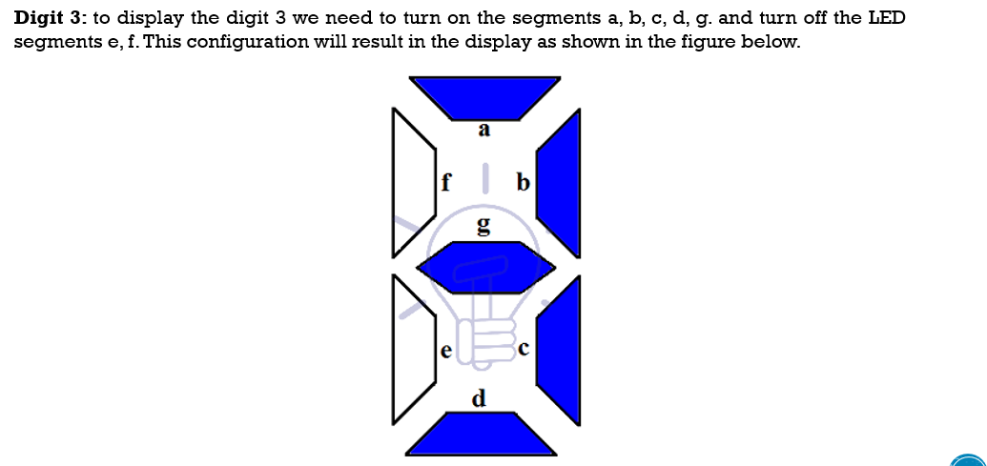
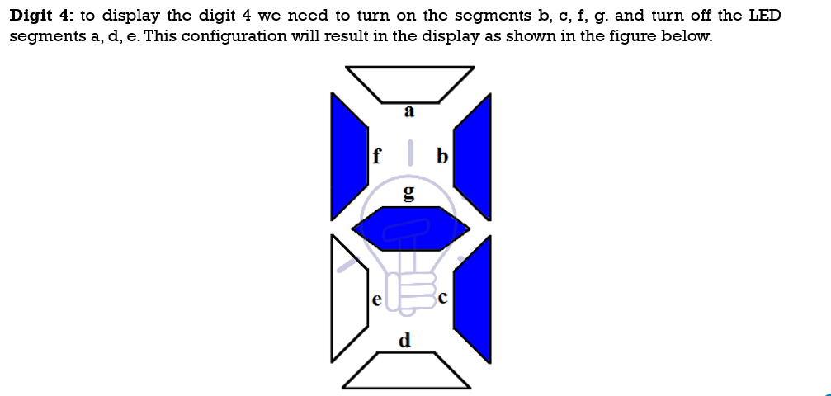

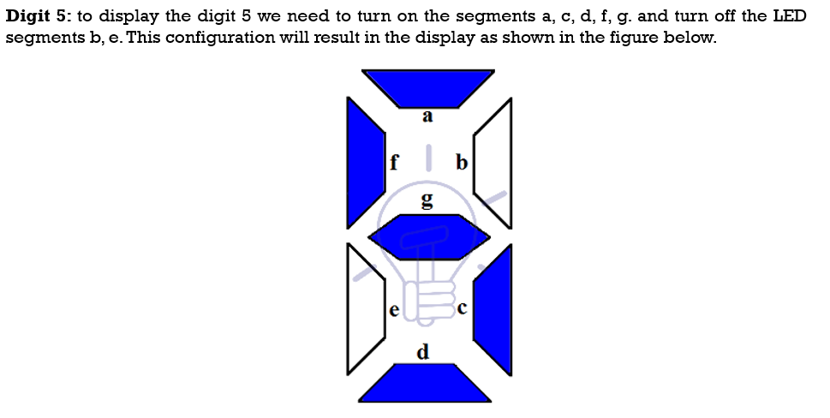

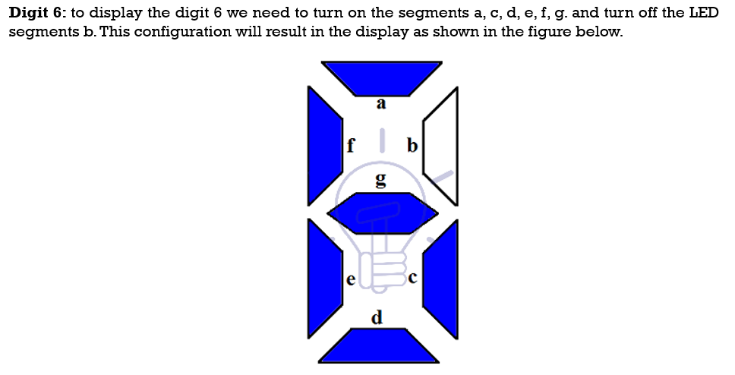

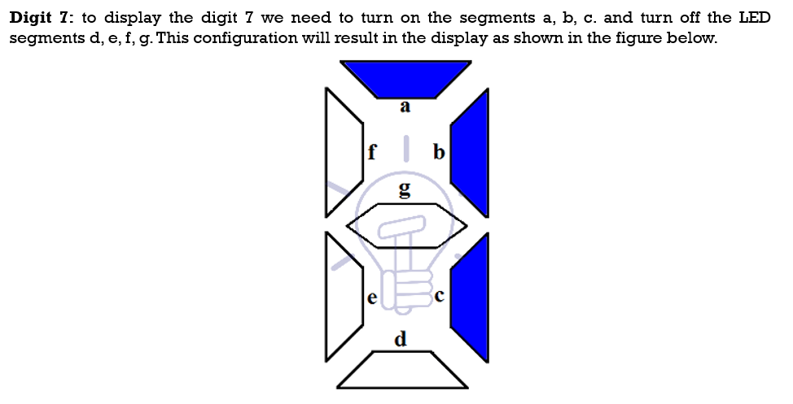

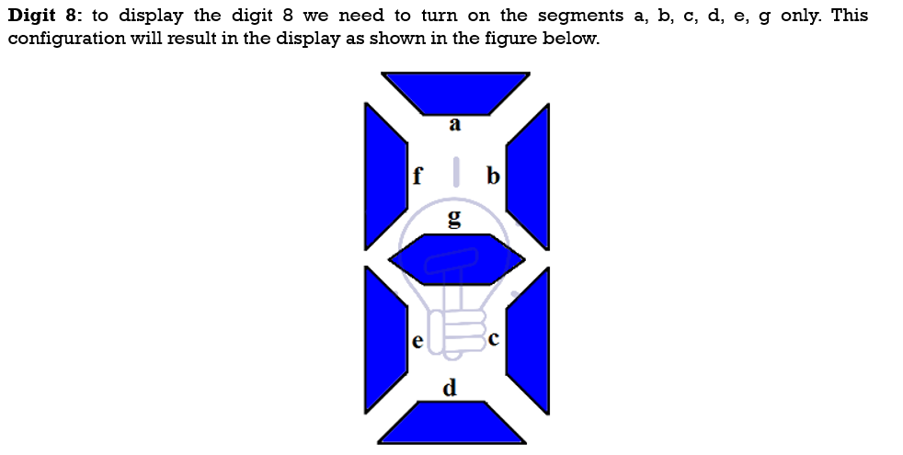

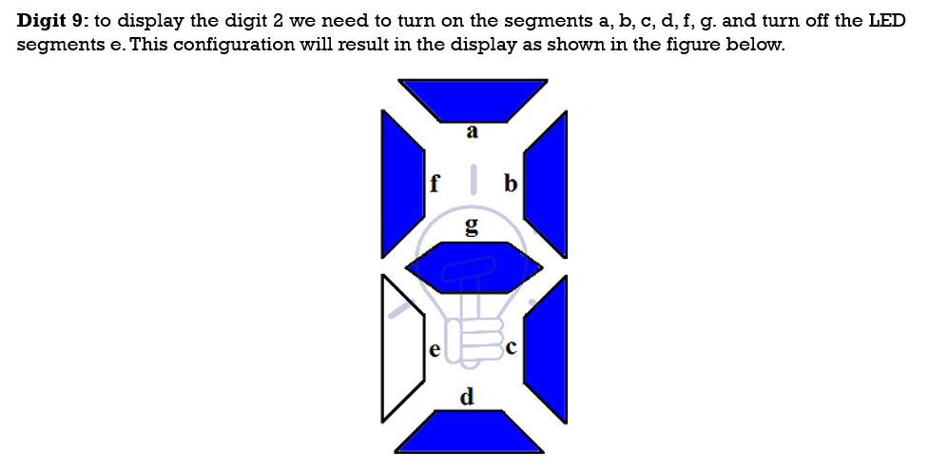

7-Segment Truth Table
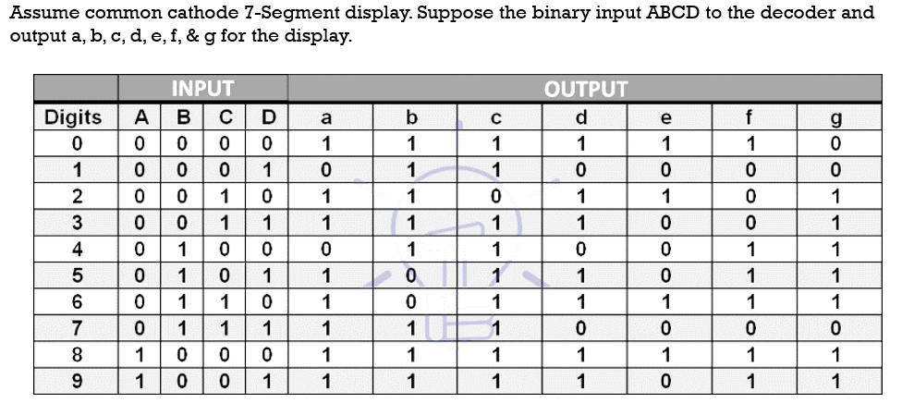

for output a:
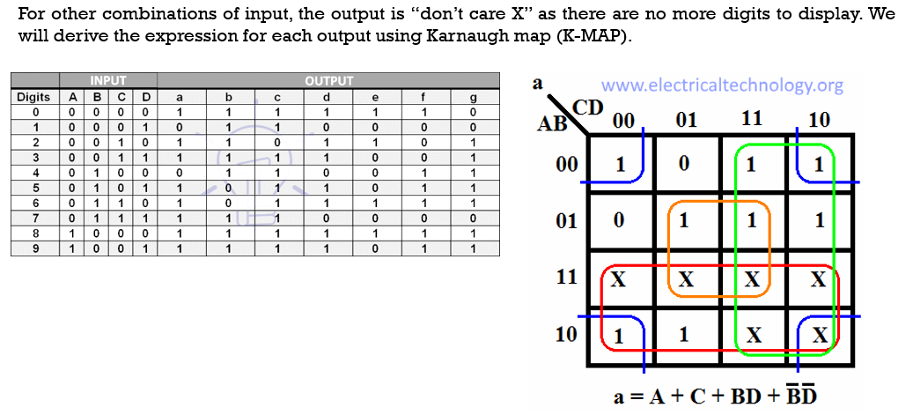for output b:
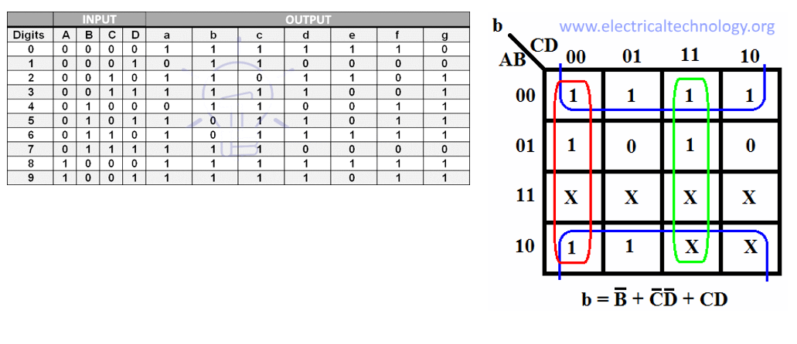for output b:

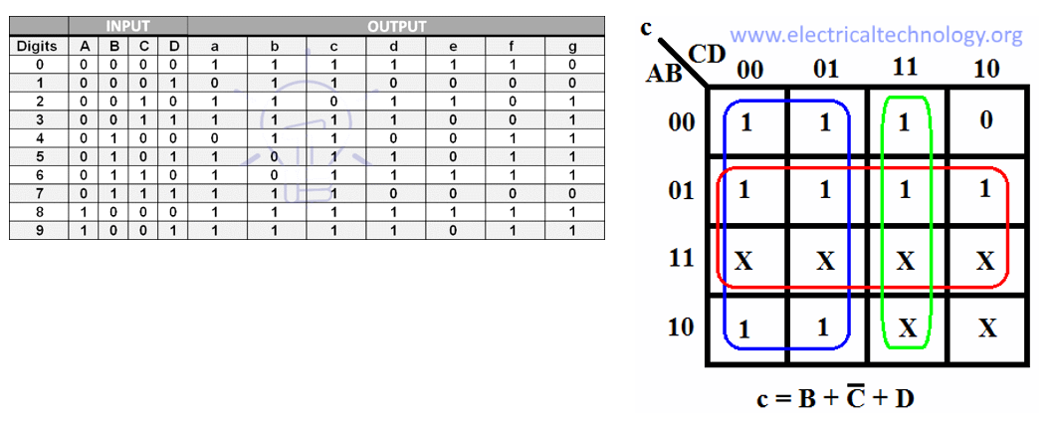for output c:
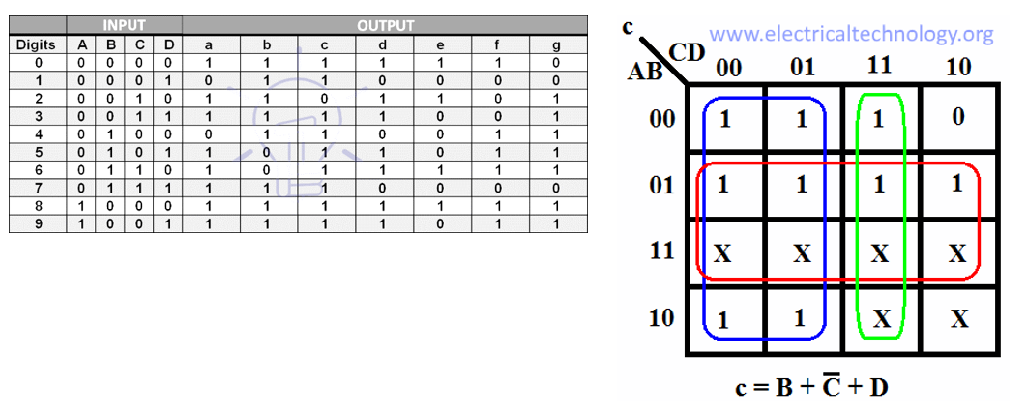for output d:
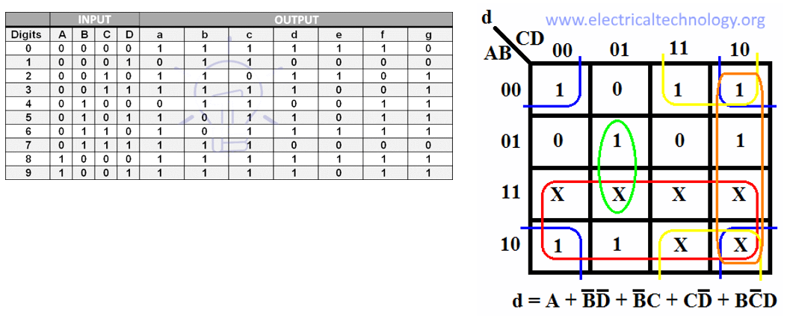
for output e:
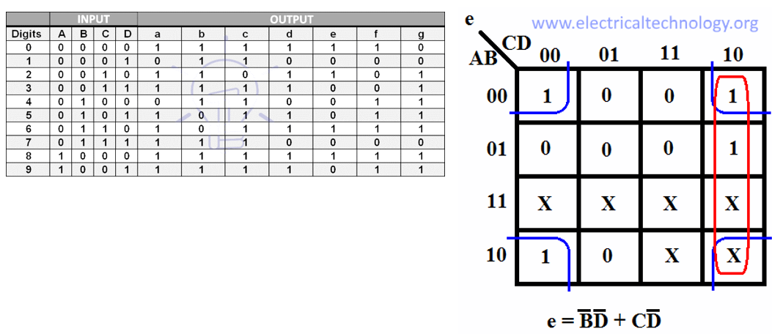
for output f
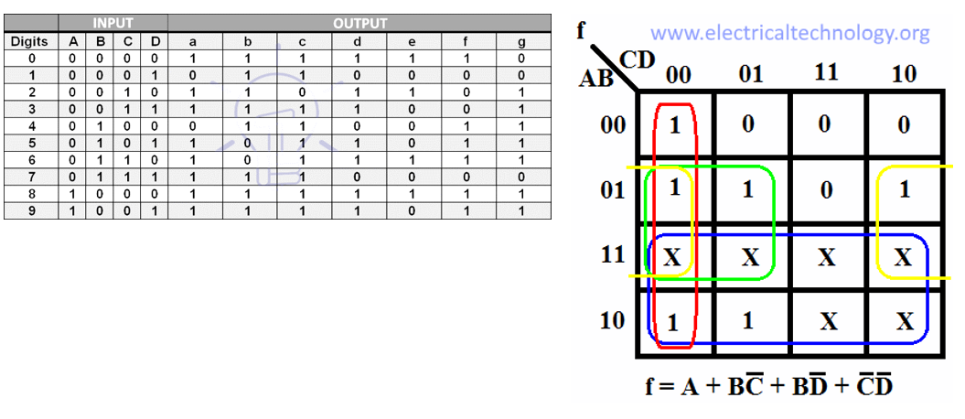
for output g
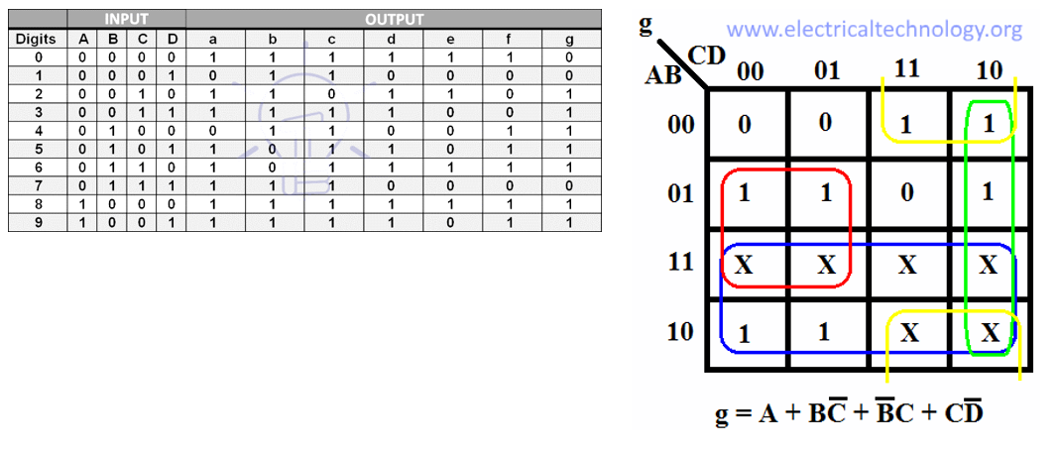

7-Segment Display Decoder Circuit
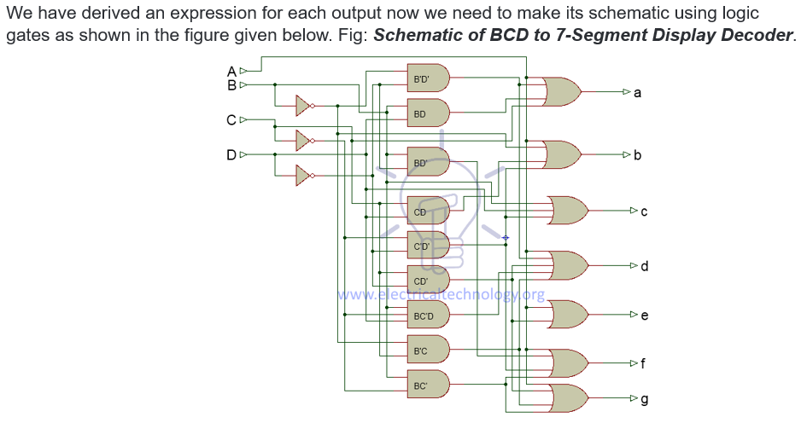

Application of BCD to Display Decoder
- This circuit can be used as a timer circuit.
- With little modification, it can be also used to display the number clock pulses.
- It can also be used with modification to display alphabet display system instead of decimal display system.
- 7-Segment display are mostly used in digital clocks, electronic meters, odometers as well as LCD application due to low current consumption.
- They are also used in various measuring instruments, digital watches and digital counter

IC-74LS47 Implementation in Multisim
